**HOME SCREEN**

**RETREIVING FILES IN ASCENDING ORDER**

**FILE HANDLING MENU**

**ADDING FILE**

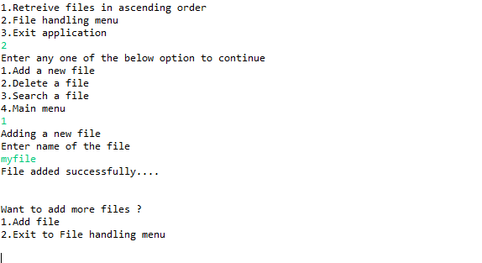

**DELETING FILE**

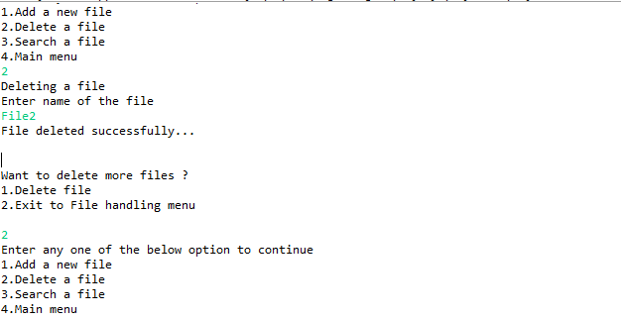

**SEARCHING FILE**

